Captsone Document

**Project Title**- Advanced ETL Pipeline for Real-Time Fraud Detection and Customer 360 in Global Banking

**#Create Data using Faker Library(data.py)**

Code has been saved in data.py file

**#Created python script which will execute data.py and save data to AWS bucket.**

Code has been saved in data_loading_boto.py

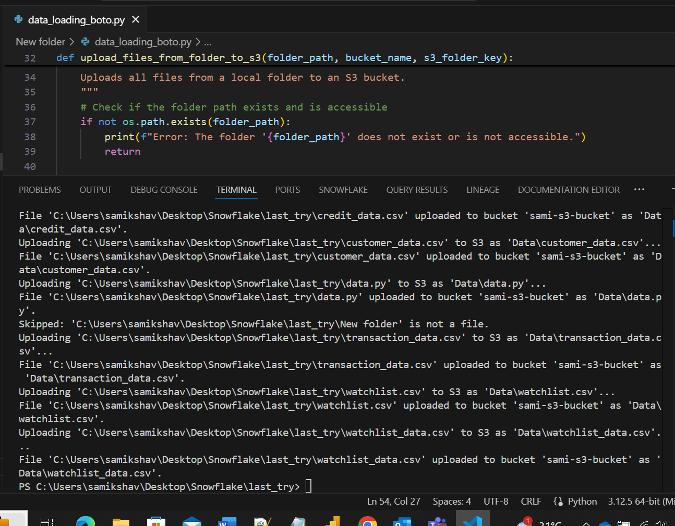

1. **Data Ingestion and Storage**:

**A-**Create database and schema

create or replace database GLOBALBANK;

create or replace schema GLOBALBANK.raw_data;

create or replace schema GLOBALBANK.transform_data;

create or replace schema GLOBALBANK.analytics;

create or replace schema GLOBALBANK.security;

**B**- Create Tables

---Create transaction table

create or replace table GLOBALBANK.raw_data.transacation_raw(

transaction_id STRING,

customer_id STRING,

transaction_date TIMESTAMP_NTZ,

amount FLOAT,

currency STRING,

transaction_type STRING,

channel STRING,

merchant_name STRING,

merchant_category STRING,

location_country STRING,

location_city STRING,

is_flagged BOOLEAN

);

---Create customer table

create or replace table GLOBALBANK.raw_data.customer_raw(

customer_id STRING,

first_name STRING,

last_name STRING,

date_of_birth DATE,

gender STRING,

email STRING,

phone_number STRING,

address STRING,

city STRING,

country STRING,

occupation STRING,

income_bracket STRING,

customer_since DATE

);

---Create Account table

create or replace table GLOBALBANK.raw_data.account_raw(

account_id STRING,

customer_id STRING,

account_type STRING,

account_status STRING,

open_date DATE,

current_balance FLOAT,

currency STRING,

credit_limit FLOAT

);

---Create Credit table

create or replace table GLOBALBANK.raw_data.credit_raw(

customer_id STRING,

credit_score INT,

number_of_credit_accounts INT,

total_credit_limit FLOAT,

total_credit_used FLOAT,

number_of_late_payments INT,

bankruptcies INT

);

---Create Watchlist

create or replace table GLOBALBANK.raw_data.watchlist(

entity_id STRING,

entity_name STRING,

entity_type STRING,

risk_category STRING,

listed_date DATE,

source STRING);

**C- Create Storage Integration**

create or replace STORAGE INTEGRATION my_s3_integration

type = External_stage

storage_provider = s3

enabled = true

storage_aws_role_arn = 'arn:aws:iam::975050369468:role/sami-new-role'

storage_allowed_locations = ('s3://sami-s3-bucket/Data/');

desc STORAGE INTEGRATION my_s3_integration;

**D-Create File Format**

create or replace file format MY_CSV_FORMAT

type = 'CSV'

FIELD_OPTIONALLY_ENCLOSED_BY = '"'

SKIP_HEADER = 1;

**E- Create Stage**

create or replace stage GLOBALBANK.raw_data.my_s3_stage

STORAGE_INTEGRATION = my_s3_integration

URL = 's3://sami-s3-bucket/Data/'

file_format = MY_CSV_FORMAT;

list @GLOBALBANK.raw_data.my_s3_stage;

**F-Create Stream**

-- Stream for transaction_raw table

CREATE OR REPLACE STREAM GLOBALBANK.raw_data.transaction_raw_stream ON TABLE GLOBALBANK.raw_data.transacation_raw;

-- Stream for customer_raw table

CREATE OR REPLACE STREAM GLOBALBANK.raw_data.customer_raw_stream ON TABLE GLOBALBANK.raw_data.customer_raw;

-- Stream for account_raw table

CREATE OR REPLACE STREAM GLOBALBANK.raw_data.account_raw_stream ON TABLE GLOBALBANK.raw_data.account_raw;

-- Stream for credit_raw table

CREATE OR REPLACE STREAM GLOBALBANK.raw_data.credit_raw_stream ON TABLE GLOBALBANK.raw_data.credit_raw;

-- Stream for watchlist table

CREATE OR REPLACE STREAM GLOBALBANK.raw_data.watchlist_stream ON TABLE GLOBALBANK.raw_data.watchlist;

**G-Create Task**

----transaction task

CREATE OR REPLACE TASK GLOBALBANK.raw_data.transactions_tsk

WAREHOUSE = compute_wh

SCHEDULE = '1 minute'

WHEN system$stream_has_data('GLOBALBANK.raw_data.transaction_raw_stream')

AS

INSERT INTO GLOBALBANK.raw_data.transacation_raw

(transaction_id,customer_id,transaction_date,amount,currency ,transaction_type ,channel ,merchant_name ,merchant_category ,location_country ,location_city ,is_flagged)

SELECT transaction_id,customer_id,transaction_date,amount,currency ,transaction_type ,channel ,merchant_name ,merchant_category ,location_country ,location_city ,is_flagged

FROM GLOBALBANK.raw_data.transaction_raw_stream;

---customer task

CREATE OR REPLACE TASK GLOBALBANK.raw_data.customer_tsk

WAREHOUSE = compute_wh

SCHEDULE = '1 minute'

WHEN system$stream_has_data('GLOBALBANK.raw_data.customer_raw_stream')

AS

INSERT INTO GLOBALBANK.raw_data.customer_raw

(customer_id,first_name,last_name,date_of_birth,gender,email,phone_number,address,city,country,occupation,income_bracket,customer_since)

SELECT customer_id,first_name,last_name,date_of_birth,gender,email,phone_number,address,city,country,occupation,income_bracket,customer_since

FROM GLOBALBANK.raw_data.customer_raw_stream;

---account task

CREATE OR REPLACE TASK GLOBALBANK.raw_data.account_tsk

WAREHOUSE = compute_wh

SCHEDULE = '1 minute'

WHEN system$stream_has_data('GLOBALBANK.raw_data.account_raw_stream')

AS

INSERT INTO GLOBALBANK.raw_data.account_raw

(account_id,customer_id,account_type,account_status,open_date,current_balance,currency,credit_limit)

SELECT account_id,customer_id,account_type,account_status,open_date,current_balance,currency,credit_limit

FROM GLOBALBANK.raw_data.account_raw_stream;

----credit task

CREATE OR REPLACE TASK GLOBALBANK.raw_data.credit_tsk

WAREHOUSE = compute_wh

SCHEDULE = '1 minute'

WHEN system$stream_has_data('GLOBALBANK.raw_data.credit_raw_stream')

AS

INSERT INTO GLOBALBANK.raw_data.credit_raw

(customer_id,credit_score,number_of_credit_accounts,total_credit_limit,total_credit_used,number_of_late_payments,bankruptcies)

SELECT customer_id,credit_score,number_of_credit_accounts,total_credit_limit,total_credit_used,number_of_late_payments,bankruptcies

FROM GLOBALBANK.raw_data.credit_raw_stream;

---watchlist task

CREATE OR REPLACE TASK GLOBALBANK.raw_data.watchlist_tsk

WAREHOUSE = compute_wh

SCHEDULE = '1 minute'

WHEN system$stream_has_data('GLOBALBANK.raw_data.watchlist_stream')

AS

INSERT INTO GLOBALBANK.raw_data.watchlist

(entity_id,entity_name,entity_type,risk_category,listed_date,source)

SELECT entity_id,entity_name,entity_type,risk_category,listed_date,source

FROM GLOBALBANK.raw_data.watchlist_stream;

ALTER TASK GLOBALBANK.raw_data.transactions_tsk RESUME;

ALTER TASK GLOBALBANK.raw_data.customer_tsk RESUME;

ALTER TASK GLOBALBANK.raw_data.account_tsk RESUME;

ALTER TASK GLOBALBANK.raw_data.credit_tsk RESUME;

ALTER TASK GLOBALBANK.raw_data.watchlist_tsk RESUME;

**H-Create Snowpipe**

**---Create pipe for Transaction data**

create or replace pipe transacation_raw_pipe

auto_ingest = true

as

COPY INTO GLOBALBANK.raw_data.transacation_raw

FROM @GLOBALBANK.raw_data.my_s3_stage/transaction_data.csv

FILE_FORMAT = MY_CSV_FORMAT

ON_ERROR = 'CONTINUE';

alter pipe transacation_raw_pipe refresh;

select SYSTEM$PIPE_STATUS( 'transacation_raw_pipe' );

**--Create pipe for customer data**

create or replace pipe customer_raw_pipe

auto_ingest = true

as

COPY INTO GLOBALBANK.raw_data.customer_raw

FROM @GLOBALBANK.raw_data.my_s3_stage/customer_data.csv

FILE_FORMAT = MY_CSV_FORMAT

ON_ERROR = 'CONTINUE';

alter pipe customer_raw_pipe refresh;

**---Create pipe for Account data**

create or replace pipe account_raw_pipe

auto_ingest = true

as

COPY INTO GLOBALBANK.raw_data.account_raw

FROM @GLOBALBANK.raw_data.my_s3_stage/account_data.csv

FILE_FORMAT = (FORMAT_NAME = MY_CSV_FORMAT)

ON_ERROR = 'CONTINUE';

alter pipe account_raw_pipe refresh;

**---Create pipe on Credit data**

create or replace pipe credit_raw_pipe

auto_ingest = true

as

COPY INTO GLOBALBANK.raw_data.credit_raw

FROM @GLOBALBANK.raw_data.my_s3_stage/credit_data.csv

FILE_FORMAT = (FORMAT_NAME = MY_CSV_FORMAT)

ON_ERROR = 'CONTINUE';

alter pipe credit_raw_pipe refresh;

**---Create pipe on Watchlist data**

create or replace pipe watchlist_raw_pipe

auto_ingest = true

as

COPY INTO GLOBALBANK.raw_data.watchlist

FROM @GLOBALBANK.raw_data.my_s3_stage/watchlist_data.csv

FILE_FORMAT = (FORMAT_NAME = MY_CSV_FORMAT)

ON_ERROR = 'CONTINUE';

alter pipe watchlist_raw_pipe refresh;

select * from transacation_raw;

select * from customer_raw;

select * from account_raw;

select * from credit_raw;

select * from watchlist;

DBT model tables.

Models are saved in DBT_model section in github with .sql extension.

select * from PC_DBT_DB.DBT_SDHADAM.customers_base;

select * from PC_DBT_DB.DBT_SDHADAM.transactions;

select * from PC_DBT_DB.DBT_SDHADAM.account;

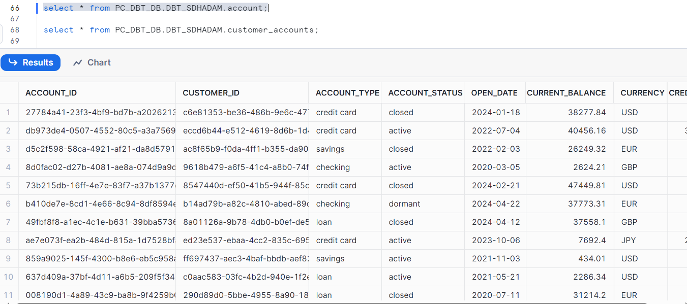

select * from PC_DBT_DB.DBT_SDHADAM.customer_accounts;

select * from PC_DBT_DB.DBT_SDHADAM.customer_spending;

select * from PC_DBT_DB.DBT_SDHADAM.customer360;

**Fraud monitoring**  
  
CREATE OR REPLACE VIEW FRAUD_MONITORING_VIEW AS

SELECT

CUSTOMER_ID,

TOTAL_SPENT,

TOTAL_TRANSACTIONS,

LAST_TRANSACTION_DATE,

CASE

WHEN TOTAL_SPENT > 10000 THEN 'High Risk'

WHEN TOTAL_SPENT > 5000 AND TOTAL_SPENT <= 10000 THEN 'Medium Risk'

ELSE 'Low Risk'

END AS RISK_LEVEL

FROM CUSTOMER360

ORDER BY TOTAL_SPENT DESC;

select * from FRAUD_MONITORING_VIEW;

SELECT MIN(TOTAL_SPENT) AS MIN_SPENT, MAX(TOTAL_SPENT) AS MAX_SPENT

FROM CUSTOMER360;

SELECT

RISK_LEVEL,

COUNT(*) AS CUSTOMER_COUNT

FROM FRAUD_MONITORING_VIEW

GROUP BY RISK_LEVEL

ORDER BY CUSTOMER_COUNT DESC;

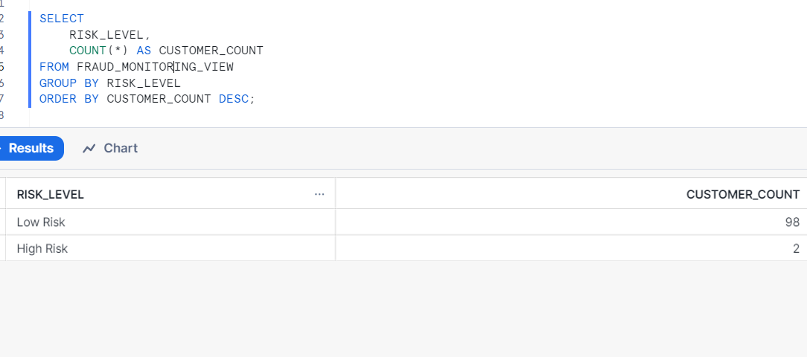

SELECT

MIN(TOTAL_SPENT) AS MIN_SPENT,

MAX(TOTAL_SPENT) AS MAX_SPENT,

COUNT(CASE WHEN TOTAL_SPENT > 10000 THEN 1 END) AS HIGH_RISK_COUNT,

COUNT(CASE WHEN TOTAL_SPENT > 5000 AND TOTAL_SPENT <= 10000 THEN 1 END) AS MEDIUM_RISK_COUNT,

COUNT(CASE WHEN TOTAL_SPENT <= 5000 THEN 1 END) AS LOW_RISK_COUNT

FROM CUSTOMER360;

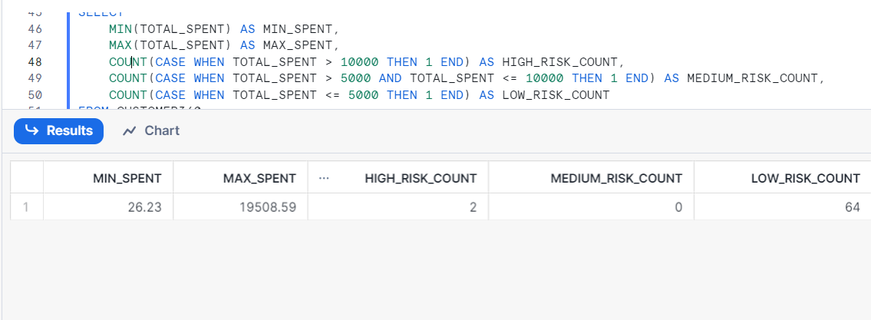

SELECT MIN(TOTAL_SPENT) AS MIN_SPENT, MAX(TOTAL_SPENT) AS MAX_SPENT

FROM CUSTOMER360;

SELECT

RISK_LEVEL,

COUNT(*) AS CUSTOMER_COUNT

FROM FRAUD_MONITORING_VIEW

GROUP BY RISK_LEVEL

ORDER BY CUSTOMER_COUNT DESC;

CREATE OR REPLACE VIEW FRAUD_MONITORING_VIEW AS

SELECT

CUSTOMER_ID,

TOTAL_SPENT,

TOTAL_TRANSACTIONS,

LAST_TRANSACTION_DATE,

CASE

WHEN TOTAL_SPENT > 10000 THEN 'High Risk'

WHEN TOTAL_SPENT > 2000 AND TOTAL_SPENT <= 10000 THEN 'Medium Risk'

ELSE 'Low Risk'

END AS RISK_LEVEL

FROM CUSTOMER360

ORDER BY TOTAL_SPENT DESC;

SELECT

MIN(TOTAL_SPENT) AS MIN_SPENT,

MAX(TOTAL_SPENT) AS MAX_SPENT,

COUNT(CASE WHEN TOTAL_SPENT > 10000 THEN 1 END) AS HIGH_RISK_COUNT,

COUNT(CASE WHEN TOTAL_SPENT > 5000 AND TOTAL_SPENT <= 10000 THEN 1 END) AS MEDIUM_RISK_COUNT,

COUNT(CASE WHEN TOTAL_SPENT <= 5000 THEN 1 END) AS LOW_RISK_COUNT

FROM CUSTOMER360;